Highlighting the benefits of Frimley Healthier Together to your patients this winter
The Healthier Together app aims to change the health-seeking behaviour of parents by providing them with the tools to evaluate the severity of their child’s illness when they are poorly.
The resources on the Frimley Healthier Together website and app have been developed in partnership between parents and healthcare professionals from across Frimley and Wexham Park using the lead and original initiative Healthier Together 0-18 pioneered by Dr Sanjay Patel. As the initiative continues to roll out nationally, we are collaborating with other regions including South Yorkshire, Wales and Hertfordshire. This provides a platform to share and discuss information amongst fellow clinicians and provide consistency in the messages we provide.
New for Winter 2023/24, the app now also provides advice on adult respiratory symptoms, such as cough, flu and Covid-19, and what to do if these symptoms are making you feel unwell.
Only by your practice formally onboarding will your patients have full access to the functionality of the app. The onboarding guide can be found in the table below. For assistance please contact your local Change Manager or Dr Alexandra Streeter de Diego at a.streeterdediego@nhs.net
Below you will find examples of:
Public facing assets
- Text messages
- Social media message
- Posters
Staff facing assets
- GP testimonials
- Onboarding information pack

Public facing assets
Text message encouraging download of the app: | The NHS Healthier Together app provides clear information about what to look out for if your child is unwell and if needed it will directly inform your GP practice about your child’s symptoms. Download the app. | n/a
Social media channel | Message | Image
Instagram/Facebook/twitter | NHS advice on managing childhood illnesses is now available via a simple to use app.  Download Frimley Healthier Together – it’s like having your own personal healthcare professional in your pocket.  https://bit.ly/FHTApp | 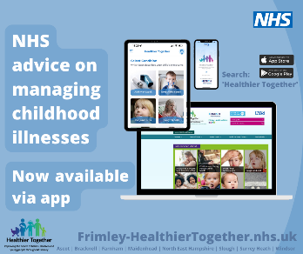
Instagram/Facebook/twitter | To help you stay in control of your child’s health, download our easy-to-use app today.  Developed by NHS professionals to provide peace of mind and help you access the best support as needed.  https://bit.ly/FHTApp | 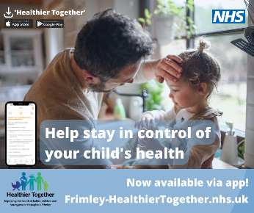
Instagram/Facebook | Are you a young person looking for information on how to manage a symptom you are experiencing?  The Frimley Healthier Together app, from the NHS, can help you with many common illnesses.  Simply download today for expert help and support.  https://bit.ly/FHTApp | 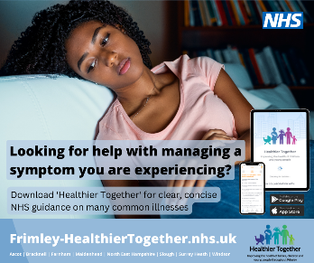
Instagram/Facebook/twitter | Having an unwell child can often be stressful.  Finding concise, reliable information on how to manage their illness is tricky at times.  To solve this the Frimley Healthier Together app is available now.  Download it today for NHS support to help you manage your child’s health right there, on your phone, when you need it.  https://bit.ly/FHTApp | 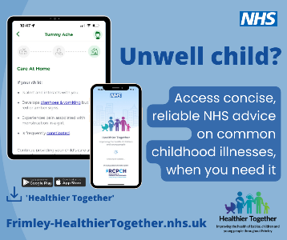
Instagram/Facebook | If you are caring for children and young people, managing their healthcare can be challenging at times.  To help, the Frimley Healthier Together app has clear information on common childhood illnesses, including advice on what 'red-flag' signs to look out for, where to seek help if required, what you should do to keep your child comfortable and how long your child's symptoms are likely to last.  Download today! https://bit.ly/FHTApp | 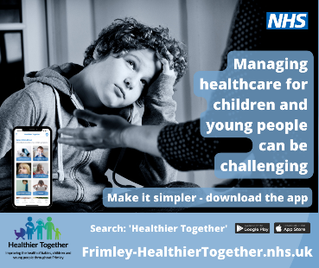
Instagram/Facebook/twitter | Access a mini doctor right there in your pocket.  The Frimley Healthier Together app is available for you to download today.  Ensure you have it at your fingertips when you need advice on managing childhood illness.  https://bit.ly/FHTApp | 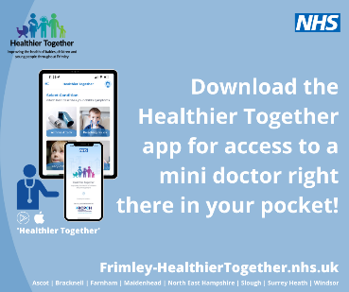
 |  | Image
 |  | 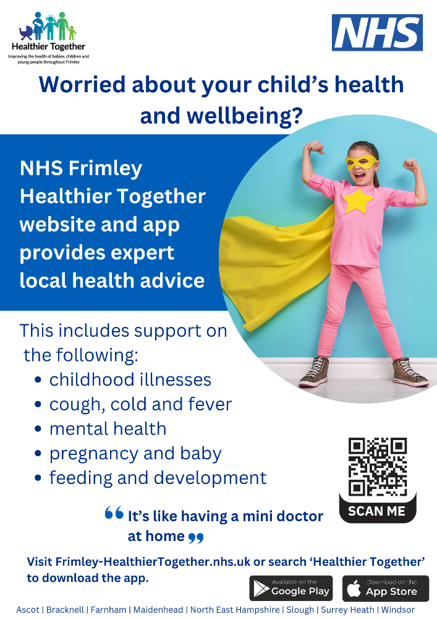
 |  | 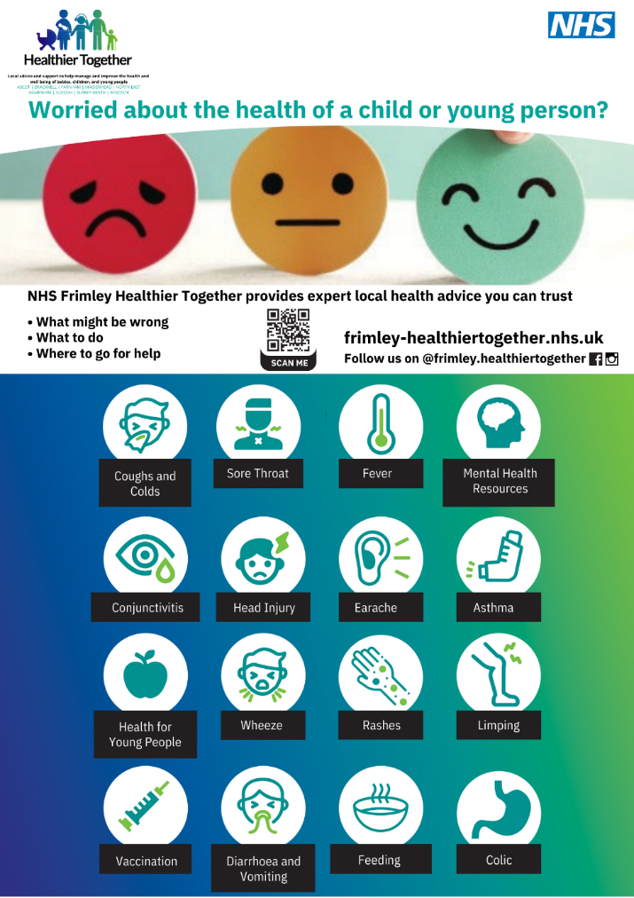
Staff assets
GP testimonals
At Bartlett Group Practice, we fully integrated Frimley Healthier Together into our patient navigation system in autumn 2022. As with any new changes, we expected some negative feedback but we have been surprised by how popular this change has been with patients and staff alike.

At the outset, we asked all parents to install the app and we continue to recommend using the app when any parent phones to request same-day access for their child. The vast majority of parents like the app. There is a lot of reassuring and helpful clinical information provided through it.

If the child does need seeing, they simply click a button on the app to submit the request. A face-to-face appointment is then arranged by the admin team, without any further triage, and passed to the parent.

The parents really appreciate avoiding the need to join a lengthy phone queue. The reception team find they have fewer stressed parents on the phone lines at peak times, trying to get an appointment for their child. The clinicians know that a number of red and green calls will have been work-flowed away from the duty team and that, for those who are seen, the clinical information submitted into EMIS through the app gives useful information before seeing the child.

Overall, integrating the Frimley Healthier Together app into our system for same-day access for children has been a huge success and we are never going back!

Dr Richard Deferrars
Partner, Bartlett Group Practice

We enthusiastically endorse the Frimley Healthier Together app for its invaluable contribution to our healthcare services at Bharani Medical Centre. During last December's group A strep outbreak, this app proved to be a game-changer.

The app's user-friendly interface and comprehensive content ensured that children could access our services promptly, while parents received vital information simultaneously. The remarkable uptake by parents demonstrated their trust in this resource, streamlining our consultations and providing consistent information during a busy time.

As we approach another season of same-day urgent care and winter pressures, we are grateful for the app's continued support. It has become an indispensable tool in our mission to deliver high-quality healthcare.

The technological healthcare revolution has been a welcome addition to our practice. The Frimley Healthier Together app represents a bright future for primary care, and we are confident it will continue to play a vital role.
In conclusion, the Frimley Healthier Together app's impact on our practice has been profound. It facilitated our response to the group A strep outbreak and positioned us well for future challenges. We wholeheartedly endorse this app for its pivotal role in providing exceptional healthcare to our patients.

Dr Bharan Kumar MD MRCGP
GP Lead:
Bharani Medical Centre Slough
Ragstone Road Surgery Slough
Cordwallis Road Surgery Slough
Woodlands Park Surgery Maidenhead
Clinical Director SHAPE Primary Care Network

The Healthier Together app has greatly improved the triage of our patients at Farnham Dene Medical Practice before they even reach us, helping us use our capacity - especially over the winter months - for those that really need it.

Our experience with e-Consult and Patches is whilst they will collect the information, all children, even with those a minor illness that can be self-cared, will come through requiring a doctor to review and frequently results in a telephone call at the minimum.

In contrast the Healthier Together app does this telephone triage appropriately directing ONLY those that truly need GP contact to the practice. It also gives those directed to self-care good practical advice meaning few patients are unhappy with the outcome and it appropriately directs very unwell children to ED avoiding duplication or delay.

Our two most successful ways of promoting the app have been:
1. Text message to all children under 18
2. Reception re-directing calls to the app

Parents themselves seem to like the speed at which they can access advice rather than waiting for a callback and we have not seen abuse of the direct email access as they can only use this if have been appropriately taken down this route by the app. Having this method of contact improves the trust the patient has in the app and reduces their worry of self-caring at home without being able to access help in a timely manner, should their child become more unwell. This in turn reduces unnecessary GP contacts.

We would highly recommend the app to all practices wanting to utilise their capacity effectively this winter.

Dr Alexandra Streeter de Diego
GP Partner, Farnham Dene Medical Practice

Onboarding pack

